Dear students,

Earlier this year, we began working with the University of Bristol’s Centre for Innovation and Entrepreneurship, with first year Design Future students presenting ideas on how motorway service areas will need to transform over the next 20+ years.

We have been astonished by the incredible level of engagement, imagination, understanding and sustainable thinking that has been shown by students, which was demonstrated in the presentations they gave to members of the Roadchef board recently. As a result, we have decided to extend our work with the university to unleash its full creative potential.

Today we are launching a competition to design the Service Station of the Future, with the most inspiring concepts winning a cash prize.

Along with our corporate commitment to becoming net zero by 2040, we have a pivotal role to play in helping the country navigate its Electric Vehicle revolution. Today, more than 52 million customers stop at our 30 sites across the UK. We need to ensure we can delight and destress customers by providing the best catering and restroom facilities, but also provide adequate charging points for those needing to charge their vehicles.

Working in groups of up to four students (from any subject area), we’re looking for ideas and frameworks that are ground-breaking, progressive, exciting, and perhaps slightly whacky! Above all, they must be grounded in sustainable thinking, with careful consideration around how your idea would help Roadchef reduce its environmental impact.

Final concepts must be submitted by Friday 15 December 2023 17.00 and will be reviewed by the board of directors at Roadchef. The most impressive idea(s) will win a cash prize (a total of £1,500 is up for grabs) along with the potential to work with the business to bring your concept to life in a real-life scenario.

I look forward to seeing what you think the ‘Service Station of the Future’ looks like. Good luck!
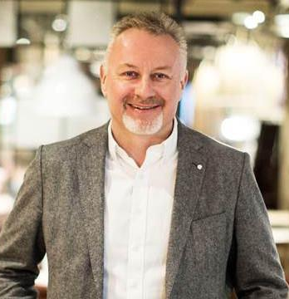
Mark Fox,
CEO at Roadchef

Key Information:

Submission date: Friday 15 December 17.00

Submission format: Via email (email address will be supplied) in PDF, MP3 or MP4 Format

Briefing session: A briefing session with take place with the CEO of Roadchef and members of the board where you can find out more about the project and ask direct questions of the team. This will take place online on Tuesday 3 October at 14.00. Please email danella.jenkins@bristol.ac.uk if you would like to take part.

Week 4 (w/c 16 October) : We (the Centre for Innovation and Entrepreneurship - CFIE) will run an open design session to support you with the development of your ideas

Week 6: (w/c 30 October ) it's Reading Week for the Faculty of Arts so we at CFIE are happy to support participants and groups with idea development and prototyping where needed

Week 8/10 (w/c 13 November ) CFIE will run online support sessions for groups prior to submission

Week 12: Final submissions: Friday 15 December 2023 17.00

Finalists will be notified in January 2024

